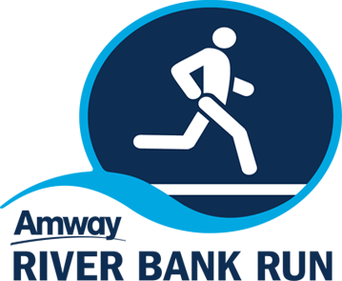

**2024 AMWAY RIVER BANK RUN**

**CHARITY PARTNER PROGRAM**

***Charity Partner Benefits:***

* Name/logo in ad materials (i.e. Website, eNews, etc.)
* Logo/link on Charity Partner dedicated Amway River Bank Run webpage
* Access to online donation page on registration platform
* 10 complimentary race entries to use as fundraiser incentive
* Option to participate at Amway River Bank Run events (ie: training runs, sponsor activities, etc.)
* Option to participate in the Family Fun area at the Junior Run on Wednesday, May 8th.
* Complimentary 10x10 booth space at the Sports & Fitness Expo at DeVos Place on Friday, May 10th and Post Race Party on Saturday, May 11th.
* Opportunity for exposure through “virtual race bags” available to participants and volunteers.
* Call to action social media campaign to encourage people to run/walk for charity
* Potential for media exposure through various media channels
* Opportunity to receive additional donations by recruiting volunteers for the Race through the Group Volunteer program (recruit 20 volunteers and receive $250)
* As a charity partner, you will be encouraged to engage employees/ customers/ volunteers to run, walk, volunteer or fundraise
* Name inclusion in a news release(s)

***Charity Partner Requirements:***

* Create a call to action by incentivizing ~~r~~unners to donate to and run for your organization (ex: receive a special shirt if you donate $30 or more, or free dinner the night before if you donate $50 or more)
* Establish a page/link on your website that is specific to the race for participants to learn more about your partnership with the race and how their donations will be used
* Call to action social media campaign to encourage people to run/walk in the 2023 Amway River Bank Run in support of your charity
* Ability to create a Charity Ambassador that can be present on social media and help to increase awareness for your charity, fundraise and promote race registration/volunteers.